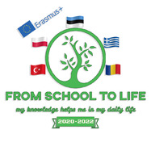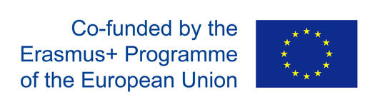
C2 ESTONIA 10−16 October 2021
Topic: Water energy and STE(A)M
PROGRAMME

TIME | ACTIVITY | REMARKS
Saturday, 9 October
 | Arrival in Tallinn
Sunday, 10 October
 | Accommodation - hostel at the sports centre. | NB!  Rapid COVID-19 test at reception (free of charge)
 | Monday, 11 October
8.oo  9.00  10.30  13.00  14.00  20.00 | Breakfast at the sports centre.  Welcoming ceremony.  Traditional dances and music performance.  School tour. Getting to know each other – icebreaking activities. A detailed programme is shared with participants  Lunch at school.  A visit to Clean Water Theme Park  Dinner at the sports centre. | NB! Bring along waterproof footwear (rubber boots)
 | Tuesday, 12 October
8.00  9.00  11.00  13.00  14.00  17.00  18.00  19.00 | Breakfast at the sports centre.  Participants work in international groups and do tasks – STE(A)M (Physics, Maths, English, Art).  Worksop 1 “Estonian Energy” (Energy usage in Estonia – strengths and weaknesses)  Peer learning activities – “Enefit Green” and enegy production in Estonia  Lunch at school  Workshop 2 – Water and symbolism in art, fiction, science fiction, science, religion.  Reena Curphey’s exhibition  Activities at the sports centre  Dinner at the sports centre. | Each country will give a presentation on this topic – in short water used in art, how it is reflected in literature by writers, its connection with religion. The length of the presentation – 20 minutes.
 | Wednesday, 13 October
8.00  9.00  19.00 | Breakfast at the sports centre.  A Field trip to the Estonian Mining Museum  THE PRICE INCLUDES:  - lunch at the museum  - underground trip in the mine  - quarry safari  Dinner at the sports centre. | Vaccination certificate required for entrance!
 | Thursday , 14 October
8.00  9.00-15.00  16.00  18.00  20.00 | Breakfast at the sports centre.  A field trip to Iru Power Plant (waste-to-energy) and Keila-Joa Hydro-electric Power Station.  Lunch (Telliskivi creative city)  Workshop 3 –Robotics: divided in multicultural groups, students design and build a hydro-mill.  Dinner at the sports centre. | Vaccination certificate!
 | Friday, 15 October
8.00  9.00  13.00  14.00  18.00 | Breakfast at the sports centre.  Presentation of students’ projects in closing meeting. Watching video diaries.  Feedback. Final evaluation.  Kahoot! on the knowledge gained during the week  Lunch at school  Porkuni – the Limestone museum  Awarding Certificates.  Farewell dinner and final evening at the sports centre | Vaccination certificate!
 | Saturday, 16 October
8.00 | Breakfast at the sports centre  Departure of guest students and teachers
EACH COUNTRY WILL MAKE A VIDEO DIARY OF THE WEEK

